CASTROL HONDA SUPERBIKE WORLD CHAMPIONS
COPYRIGHT  1998 INTERACTIVE ENTERTAINMENT LTD

ONE TRACK DEMO VERSION

INTRODUCTION 2
The Team 2
The Bike 2
QUICK START INSTRUCTIONS 3
Installation 3
THE RACE 4
Replay 4
Jump Starts & The Stop-Start Penalty 4
Appendix A RC45 TECHNICAL SPECS 5
Appendix B IN-GAME KEYS 6
Appendix C DEFAULT CONTROLS 7
Appendix D CREDITS 8

WWW.TEQUE.CO.UK

INTRODUCTION

Officially licensed and developed with the 1997 World Champions, Castrol Honda Superbikes is a blistering motorcycle racing simulation. Every aspect of the 1997 World Championship winning bike: the awesome 190 MPH 160 BHP Honda RVF-RC45 is simulated. To win the championship you will have to master the bike and its setup for every track. Multiple options are included to allow complete control of the simulation environment, from the level of your computer opponents to tyre wear and whether or not an accident will put you out of the race.

The Team

Castrol Honda entered the World Superbike arena in 1994 with the brand new RC45. Since those early days the Castrol Honda team has never finished outside the top three in the series and achieved the ultimate in 1997 when
American John Kocinski clinched the world title.

Castrol Honda has now become the most respected team in the paddock. During four seasons in the championship the team has earned 2382 points, including a sensational 1997 when Castrol Honda took the riders', manufactuers' and coveted teams' titles.

No one at Honda is resting on that success. The battle for World Superbike success continues as Castrol, Honda and the committed group of technical sponsors go in search of perfection.

WWW.CASTROL-HONDA.COM

The Bike

Performance

Max Speed 187 mph
Acceleration 0-60mph 3.1 seconds
0-100mph 4.9 seconds

This is what the team say about the RC45:

"The Castrol Honda has developed into the all-round package. Not only is the bike a championship winner but it is a potential race winner at every circuit we visit.

It may be 162 kilograms of metal but it accelerates like a Formula One car and offers the stopping power to match anything around.

The bike has the agility to tackle and master anything thrown in front of it, from the infamous 'Corkscrew' at Laguna Seca in America to the power-sapping 200mph straights of Hockenheim in Germany.

This machine is a dream to ride . It is the most technical in the World Superbike pitlane, master it and you'll be world champion."

Full technical specs on the bike are contained in Appendix A.

The Most Accurate Motorbike Simulation Ever Made

QUICK START INSTRUCTIONS

Installation
Insert the CD-ROM into your drive. The installation shield should run automatically within a few seconds. If not double click on your CD-ROM icon or open your CD-ROM (in you’re My Computer folder) and double click on the setup.exe program.

Follow the on screen instructions to install Castrol Honda Superbike World Champions.

When installation is complete the simulation will run.

You will need to have Direct X Version 5.0 or higher installed - if not this will install automatically from the CD. Also ensure that you have the latest drivers for your video card. If you have access to the Internet then go to the website of your card's manufacturer.

Joystick, Keyboard, Mouse Control

The bike can be controlled by keyboard, joystick (including wheels and flight yokes) or mouse. It is recommended that a joystick or steering wheel is used. If you use a joystick or wheel first ensure that it is calibrated correctly using the Windows Control Panel.

NOTE: JOYSTICK CONTROL ONLY IS SUPPORTED IN THIS DEMO.

The default setup for the different control methods are as follows:-

ACTION | JOYSTICK
Throttle | Joystick Forward
Brake | Joystick Back
Steer | Joystick Left/Right
Change Up A Gear | Fire Button 1
Change Down A Gear | Fire Button 2
Reverse View | Fire Button 3

In game use the SPACE BAR to pause the game. To Quit press ESC whilst paused.

Run the game by clicking on the Castrol Honda icon in your install directory. Remember that if you wish to use a joystick you will need to have already calibrated it in Windows.

In this demo you will start at the back of the grid at Sukuh Island circuit in Indonesia, in Rookie Single Race mode. This is the easiest level. In the full version of the simulation you can choose from five levels from Rookie to Ace.

THE RACE

Wait for the start lights to light up (one after the other) and then go out. These are repeated in the top left-hand corner of the screen as well as appearing on the gantry at the start line. Don't start moving before the lights have gone out or you will get a jump start penalty and your race results will be disallowed.

The other bikes will race with each other and will make it difficult for you to overtake. Remember that your opponents will try and get to the racing line through each corner before you. You will not be able to go as fast around the inside and outsides of corners as you would if you followed the racing line and the opposition riders will take advantage of this.

Your position in the race is shown in the top left hand corner. Below this is the number of laps in the race and the lap number you are on.

Replay

At the end of the race you will be shown a replay of your entire race. The camera will automatically switch to the best view available. If you want to control the camera yourself press the 0 key on the number pad to cycle through the view available. To look at other bikes press the F11 and F12 function keys.

To quit the replay press ESC.

Jump Starts & The Stop-Start Penalty

If you move away at the start of the race before the start lights have gone out, you will get a Jump Start penalty. You will be informed of this with a message at the bottom of the screen. You MUST clear this penalty or you will lose your results. You can also get a penalty for speeding in the pit lane or other racing misdemeanors.

If you get a stop-start penalty the symbol will flash on the right hand side of the screen. You must come into the pits and stop for 10 seconds or your results will not be allowed. When you enter the pits remember that there is an 80 kmh speed limit (50 mph).

To clear the penalty stop in the coned off area in the pit lane and put the bike into Neutral. The 10 second penalty will count down. Move off when it has reached zero, but remember not to speed coming down the pit lane. If you move off too soon, or stop in the wrong place the penalty will not be cleared.

Appendix A RC45 TECHNICAL SPECS

Make Honda
Model RC45
Team Castrol Honda World Superbike Team, Louth, Lincolnshire.

Performance

Max Speed 187 mph
Acceleration 0-60mph 3.1 seconds
0-100mph 4.9 seconds
Braking 60-0 1.9 seconds
100-0 3.3 seconds

Engine

Type Liquid-cooled 4 stroke 16 valve DOHC 90° V-4
Displacement 749.2cc
Bore x Stroke 72 x 46 mm
Max Power 160 Brake Horse Power @ 14000 rpm
Max Torque 60 ft-lbs
Compression Ratio 12.5:1

Gearbox

Gears 6 speed

Chassis

Dry Weight 162kg
Wheelbase 1415mm
Front Brake Dual Brembo 320mm Discs
Rear Brake Single Brembo 190mm Disc
Fuel Tank 22 litres

Wheels & Tyres

Front Wheel/Tyre 120/60x17 inch, Michelin 3.5x17 inch, 2.1 Bar
Rear Wheel/Tyre 18/67x17 inch, Michelin 6x17 inch, 1.9 Bar
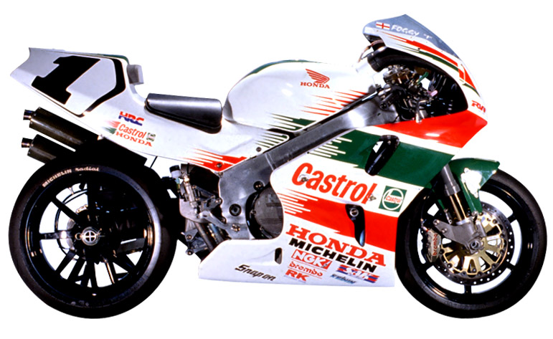

Appendix B IN-GAME KEYS

KEY | ACTION
SPACE | Pause
F1 | On screen help on/off
F2 | Turn on/off racing line
F3 | Steering assistance on/off
F4 | Brake assistance on/off
F5 | Toggle Automatic or Manual Gearbox
F6

F7

F8 | Panel on/off
F9 | Detail down
F10 | Detail up
F11 | Change bike -
F12 | Change bike +
Number Pad 0/Ins | Cycle through camera views
Number Pad 2/Down Arrow | Cycle through driving views.

PAUSE MODE KEYS | ACTION
ESC | Quit
W | Workshop
R | Replay
SPACE | Resume

Appendix C DEFAULT CONTROLS

ACTION | JOYSTICK | KEYBOARD | MOUSE
Throttle | Joystick Forward | A | Left Button
Brake | Joystick Back | Z | Right Button
Steer | Joystick Left/Right | < > | Move Left/Right
Change Up A Gear | Fire Button 1 | P | P
Change Down A Gear | Fire Button 2 | L | L
Reverse View | Fire Button 3 | M | M

Appendix D CREDITS

Lead Developer James Bailey
Front End Developer Dan Azzorpardi
Additional Developer John Rees
Additional Developer Alex Jakes
Simulation Developer Vladislav Kaipetsky

3D & Track Modeling Daren Morgan
Track Modeling Steve Morgan
Graphic Design Tuan Pingster Nguyen
2D Artist FAD

BOS Developer Barry Costas

Producer Tony Love

www.teque.co.uk

